**Unit 8 How do you make a banana milk shake?**

**Section B2 (2a-2e)**

**【学习目标】**

1. 理解并掌握下列词汇及短语：

New words: Thanksgiving, traditional, autumn, celebrate, prepare, gravy, mashed, pumpkin, pie, mix, pepper, fill, oven, plate, cover, serve, temperature

Key phrases: traditional food, give thanks for, a big family meal, fill…with…，cover…with…, place…on…, cut…into thin pieces, make dishes, at a very high temperature

理解并掌握下列句子:

1）In most countries, people usually eat traditional food on special holidays.

2）Families see Thanksgiving as a time to get together and usually celebrate it with a big family meal.

3）Here is one way to make turkey for a Thanksgiving dinner.

2. 通过逐层阅读，了解美国的感恩节以及感恩节的传统食物火鸡及制作方法。掌握一定的阅读技巧。提升阅读能力。

3. 通过学习美国特定节日的传统食物，能够联想中国节日以及家乡的风味小吃，激发对家乡的热爱之情，同时体验中西方饮食文化的差异。

**【重点和难点】**

1. New words and key phrases.

2. Tell the process of making certain traditional food on special holidays in China, such as mooncakes, dumplings, *zongzi* and so on.

**【课前预习】**

Task 1 学习词汇，巩固新知

A 单词

1. 传统的*adj.* _______________ 2. 火鸡 *n.* ________________

3. 秋天，秋季*n.* ___________ 4. 南瓜 *n.* ____________

5. 庆祝，庆贺*v.* ___________ 6. 混合，融合*v.* ________________

7. 充满，装满*v.* ____________ 8. 遮盖，覆盖 *v.* ________________

9. 服务，提供*v.* _____________ 10. 温度 *n.*

B 短语

11. 传统食物 12. 在特殊的节日

13. 感恩于 14. 丰盛的家庭大餐

15. fill…with… 16. cover…with…

17. place…on… 18. cut…into thin pieces

19. make dishes 20. at a very high temperature

1. 将下列句子翻译成中文。

21. In most countries, people usually eat traditional food on special holidays.

______________________________________________________________

22. Families see Thanksgiving as a time to get together and usually celebrate it with a big family meal.

______________________________________________________________

23. Here is one way to make turkey for a Thanksgiving dinner.

______________________________________________________________

Task 2 回答问题

1. Do you know the traditional festivals in China?

1. What do people eat on that day?

**【合作探究】**

**Step 1 Lead in**

Talk about how to make your favorite food with your partner.

A: What's your favorite food?

S: My favorite food is…/I like…best.

A: Do you know how to make it?

B: Yes, of course. First, … Next, … Then, … Finally，…

**Step 2 Pre-reading**

1. Work on 2a

检查课前预习任务2的答案。

2. Answer the following two questions.

1) Do you know the traditional festivals in the North America?

2) What do people eat on that day?

**Step 3 While-reading**

1. 请仔细阅读课文，完成下面的图表，每空不超过两个单词。

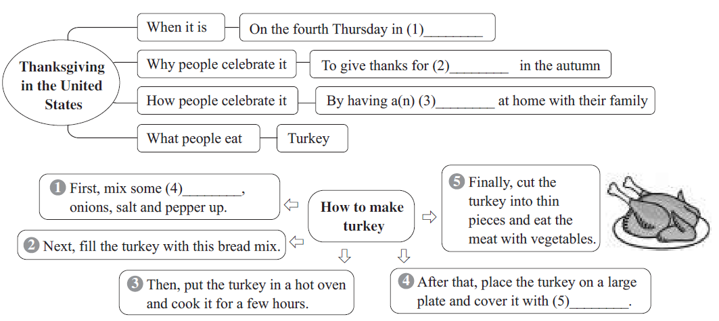

2. Finish 2d.

**Step 4 Post-reading**

Work on 2e

What do you think is the most special day in China? Answer the following questions.

1) When is this special day?

2) What are the reasons for this special day?

3) How do most people celebrate this day?

4) Is there any traditional food?

5) Can you make this dishes?

**【探究一】**

To go with the turkey, people often prepare other things, such as gravy, cornbread…

prepare *v*. 使做好准备；把……准备好

常用结构: prepare for sth. 为某事做准备

prepare to do sth. 准备做某事

prepare sb. sth. / prepare sth. for sb. 为某人准备某物

【运用】根据汉语意思完成英语句子，每空一词。

1) 张先生正在准备早饭。

Mr Zhang is _______ breakfast.

2) 你准备写信给她吗？

Do you _______ _______ _______ to her?

3) 我们一周前开始为这次旅行做准备。

We began to _______ _______ this journey a week ago.

4) 爸爸为我们准备了一顿美餐。

Dad _______ _______ a delicious meal.

**【探究二】**

Next, fill the turkey with this bread mix.

fill *v*. (使)充满；装满

fill常用于be filled with ... 结构中，可与 be full of ... 互换使用。

e.g. The glass is filled with water. = The glass is full of water.

【运用】

I. 用正确的介词填空

1) The room is full _______ the smell of coffee.

2) Linda filled the box _______ her books.

II. 写出同义句

The little girl's bag was filled with apples.

The little girl's bag _______ _______ _______ apples.

【探究三】

When it is ready, place the turkey on a large plate and cover it with gravy.

cover  *v*. 遮盖；覆盖

常用于 cover ... with ... 和be covered with ... 结构中。

cover *n*. ①(书刊的)封面，封皮 ②覆盖物；盖子

【运用】

I. 写出划线部分的词性及汉语意思

1. People shouldn't choose a book by its cover. _____________

2. Look! The little boy is covering his dad with sand on the beach. __________

3. The sun is out. You can take the cover off the corn. _____________

II. 汉译英

因为我要外出很长时间，所以刚才我用布盖住了沙发。

_____________________________________________

【探究四】

…serve it to your friends with some vegetables.

serve *v*. ① (在商店中)接待(顾客等)

② 为……服务/ 工作

③ 提供(食物、饮料等)，端上(饭菜等)

常用结构：serve sth. to sb.

serve sb. sth.

serve sb. with sth.

【运用】完成句子

1) Jack将在明晚的派对上为我们提供饮料。

Jack will _______ _______ _______ _______ at the party tomorrow night.

2) 你们餐厅晚上11点招待人吗?

Do you _______ _______ at 11:00 p.m. in your restaurant?

3) 这些警察在默默地为人民服务。

These policemen _______ _______ _______ _______ quietly.

【探究五】

Cook it at a very high temperature for a long time.

temperature *n*. 温度; 气温; 体温

(既是可数名词，也是不可数名词)

通常用high / low来表示温度的“高 / 低”。

询问“温度是多少”时，用What's the temperature?。

常用搭配：at a high / low temperature在高 / 低温下

at room temperature在室温下

have / run a temperature发烧

take one’s temperature 给某人量体温

【运用】完成句子或对话

1) It's so hot that we have to keep our food _______ _______ _______ _______(在低温下).

2) —_______ _______ _______(温度是多少) in your room?

—It's 25℃.

3) Bob looks uncomfortable, and I will _______ _______ _______(给他量体温).

【探究六】

1. First, put some butter on a piece of bread.

② Finally, cut the turkey into thin pieces and ...

两句中的piece都作名词，都意为“片”。

piece常用于表示不可数名词的量，可意为“片；块；张；条……”，常用结构为“a / another / 数词+ piece(s) of +不可数名词”。

e.g. a piece of wood 一块木头

another piece of meat 另一块 / 片肉

two pieces of advice两条建议

three pieces of paper三张纸

【运用】完成句子

1) 你能再给我一张纸吗？

Can you give me _______ _______ _______ _______?

2) 我妈妈能把土豆切成很薄的片。

My mother can cut the potato into very _______ _______.

**【课时小结】**

本节课我们学习了美国感恩节的由来以及火鸡的制作流程。

单词: Thanksgiving, traditional, autumn, celebrate, prepare, gravy, mashed, pumpkin, pie, mix, pepper, fill, oven, plate, cover, serve, temperature

词组: traditional food, on special holidays, give thanks for, a big family meal，fill…with…, cover…with…, place…on…, cut…into thin pieces, make dishes, at a very high temperature

句型:

1) In most countries, people usually eat traditional food on special holidays.

2) Families see Thanksgiving as a time to get together and usually celebrate it with a big family meal.

3) Here is one way to make turkey for a Thanksgiving dinner.

**【达标检测】**

**I. 从方框中选择合适的单词填空, 使每个句子在结构、句意和逻辑上正确。**

|  |
| --- |
| pepper, piece, serve, plate, autumn, celebrate, mix, traditional, travel, temperature |

1. This town changed a lot. People can't see the _______ way of life there now.

2. There are only three _______ of cake left. Would you like one?

3. The leaves are turning yellow. The _______ is coming.

4. The guide is booking the hotels for the _______.

5. Bert _______ the New Year with his friends last night.

6. I'd like to add some _______ to the soup. It tastes delicious.

7. Marie _______ the milk with the honey and it tastes good.

8. These bowls are too small, and we need to buy some _______ for fish.

9. In the future, the robots will help us work at a high _______.

10. The hotel _______ us breakfast this morning, so we came here after breakfast.

**II. 根据汉语意思，完成英语句子，每空一词(含缩略形式)。**

1. 你能把牛肉切成片吗？

Can you _______ _______ _______ _______ _______?

2. Jenny, 现在10点了，该回家了。

Jenny, it's 10 o'clock now. _______ _______ _______ go home.

3. 我想感谢我老师的帮助。

I want to _______ _______ _______ the help of my teacher.

4. 学生们课后一个接一个地走出了教室。

The students went out of the classroom _______ _______ _______ after class.

5. 这是可以帮助你赢得比赛的一种方法。

_______ _______ _______ _______ _______ help you win the competition.

6. 我想在这个特别的节日里给我父母做顿饭。

I want to cook a meal for my parents _______ _______ _______ _______.

7. 这位母亲用书盖住了电话，所以她的孩子找不到它。

The mother _______ _______ _______ _______ _______ _______, so her child could not find it.

8. 旅行前我把我的包里装满了衣服，因为晚上山里冷。

I _____ ______ ______ ______ ______ before the trip because it is cold in the mountain at night.

**【自我评价】**

1. 本课我学会了什么？

___________________________________________________________

2. 通过本课的学习，我还有哪些疑问？

___________________________________________________________

**参考答案：**

**【课前预习】**

Task 1

1. traditional 2. turkey 3. autumn 4. pumpkin 5. celebrate 6. mix

7. fill 8. cover 9. serve 10. temperature

11. traditional food 12. on special holidays

13. give thanks for 14. a big family meal

15. 用……填满…… 16. 用……覆盖住…… 17. 把……放置在……上18. 把……切成薄片 19. 做菜肴 20. 用很高的温度

21. 在大多数国家，人们通常在特别的日子里吃传统食物。

22. 人们认为感恩节是一个家庭团聚的时刻，而且通常会用一顿家庭大餐来庆祝。

23. 下面是感恩节大餐中火鸡的一种烹饪方法。

**【合作探究】**

**Pre-reading**

**2. 1) Thanksgiving. 2) Turkey.**

**While-reading**

1. November 2. food 3. big meal 4. bread pieces 5. gravy

**【探究一】**

**1) preparing 2) prepare to write 3) prepare for 4) prepared us**

**【探究二】**

I. 1) of 2) with Ⅱ. was full of

【探究三】

I. 1) 名词，封面    2) 动词，遮盖     3) 名词，覆盖物

II. I covered the sofa with the cloth just now because I will go out for a long time.

【探究四】

1) serve us with drinks / serve drinks to us

2) serve people

3) are serving the people

【探究五】

1) at a low temperature 2) What's the temperature 3) take his temperature

【探究六】

1) another piece of paper 2) thin pieces

**【达标检测】**

I. 1. traditional   2. pieces       3. autumn  4. travelers    5. celebrated

6. pepper      7. mixes     8. plates 9. temperature     10. served

II.1. cut the beef into pieces

2. It's time to

3. give thanks for

4. one by one

5. Here is one / a way to

6. on this special holiday

7. covered the phone with a book

8. filled my bag with clothes